Assignment 1.6 – classification:
Summary:
- I loaded my data file, which is temp.arff.
- I selected three attributes because if I select more than three I will have memory problem, since a nominal attribute can have many values so its test conditions can be expressed in multi way split, I will convert my selected attributes into nominal. There fore, my selected attributes are:
- Age
- Dis-position
- Length of stay
- My steps are using mouse to select attributes/invert/remove, then go to filtering to select NumericToNominal so that means covert it to binary attribute type I got nice graph see figure-(1) below.
- Then select Classify icon/select Classifier type I select ZeroR type first, Fold of Cross- validation is (3), then started so I obtained
Correctly Classified Instances 4405 11.828 %
Incorrectly Classified Instances 32837 88.172 %, see the
results file in excel file:
  - My goal is to select classifier type that gives less error rate or better Correctly Classified rate (percentage).
- I selected simple Card type, and then started classifying so it took quite long time.
From the results of simple Card I beat the ZeroR classifier
Because that the correctly rate of Classified is increased to 13.4472 %
Correctly Classified Instances 5008 13.4472 %
Incorrectly Classified Instances 32234 86.5528 %
- See also the graph (2), for visualized classifier error/dis-position.
- Using j48 classifier I obtained better results than ZeroR classifier
Where the error rate is is smaller than in case of ZeroR.
Correctly Classified Instances 4905 13.1706 %
Incorrectly Classified Instances 32337 86.8294 %
- Figure (3), shows the decision tree.
- Figure (4), shows the visualized classifier error/dis-position.
We can note that it is more than in case of simple card
10. Figure (5), shows the visualized classifier error/dis-position
In ZeroR classifier, this has higher error rate.
11. to make the classification more effective ,we use alternative
Techniques for building classification
Models such as rule-based, which used a collection of “if…then”
And nearest – neighbor classifier or support vector machine and
Ensemble methods.
Figure (1).
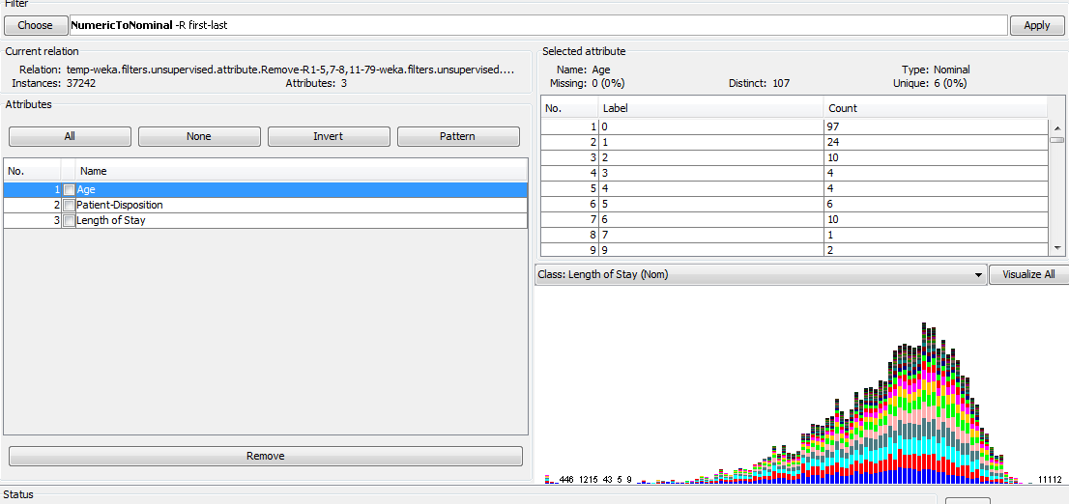

Figure (2).
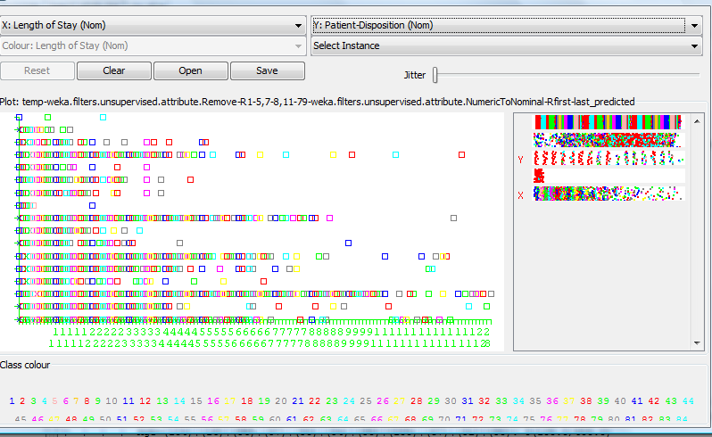

Figure (3).

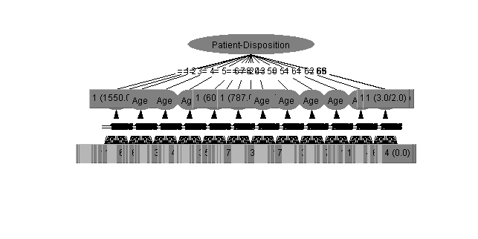
Figure (4).

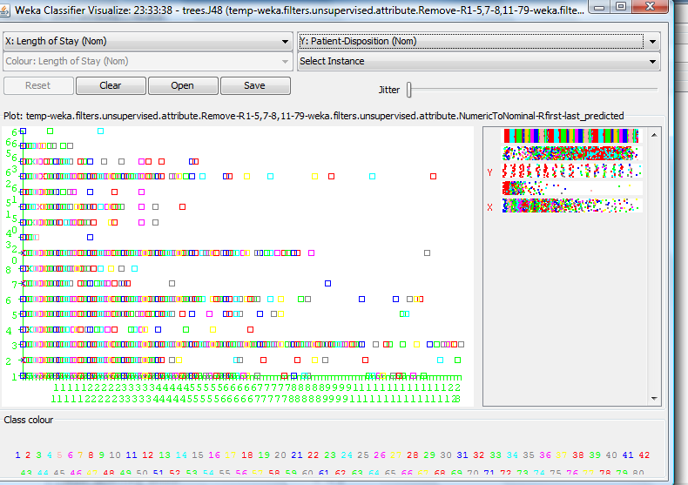

Figure (5).
